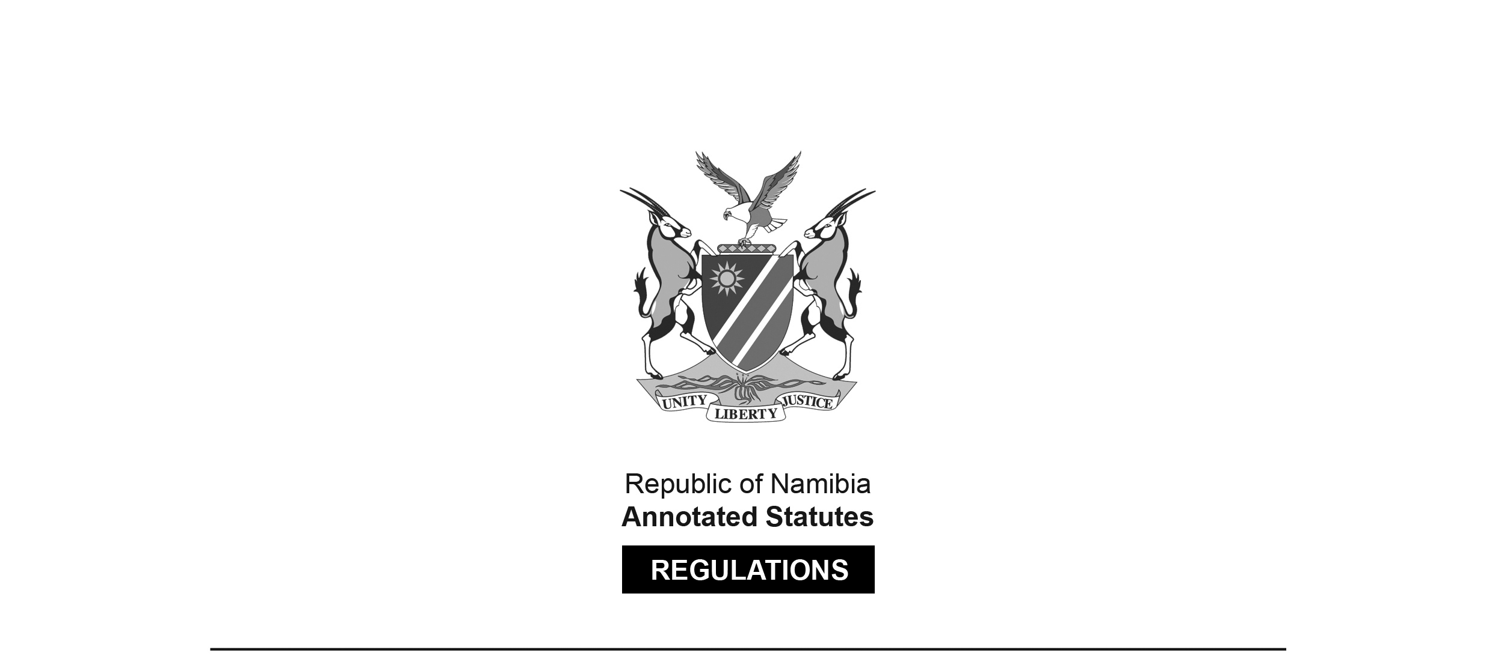

REGULATIONS MADE IN TERMS OF

Payment System Management Act 14 of 2023

section 47 read with sections 10(2) and 11(3)

Regulations relating to Fees payable to Bank of Namibia

Government Notice 252 of 2023

([GG 8171](https://www.lac.org.na/laws/2023/8171.pdf))

came into force on date of publication: 8 August 2023

The Government Notice that publishes these regulations notes that   
they were made on the recommendation of the Bank of Namibia.

ARRANGEMENT OF REGULATIONS

1. Definitions

2. Fees payable for non-refundable application fees

3. Methods of payment

**Definitions**

**1.** In these regulations a word or an expression to which a meaning has been assigned in the Act has that meaning, and unless the context indicates otherwise -

“the Act” means the Payment System Management Act, 2023 (Act No. 14 of 2023).

**Fees payable for non-refundable application fees**

**2.** A person who wishes to apply for a licence under section 10(1) of the Act or authorisation under section 11(3) of the Act must pay the following non-refundable fees to the Bank -

(a) N$5000 for an application for a payment service provider licence; and

(b) N$5000 for an application for authorisation as a payment system operator.

**Methods of payment**

**3.** (1) The fees payable as set out in regulation 2 must be paid to the Bank by transfer into a bank account nominated by the Bank in writing from time to time.

[The subregulation number “(1)” above appears to be in error,   
as there are no other subregulations in regulation 3.]